# Users SOP

## Creating new users

For all new users **WITH AN EMAIL ADDRESS**, follow this procedure:

1. Navigate to the Users App from the *Apps Menu*
2. Select “Add New User” from the bottom right corner
3. Fill in the user’s details (First and last name, email, phone)
4. Assign them to user role(s), group(s) and organisation unit(s) using Table 2 as reference within the section User Role(s), Group(s) and Organisation Unit Assignment by User Type
5. Generate a password for them using the process described in the section Generating a Password (for users with an email)
6. Share the account details as described in the section Sharing Account Details (for users with an email)

For all new users **WITHOUT AN EMAIL ADDRESS**, follow this procedure

1. Navigate to the Users App from the *Apps Menu*
2. Select “Add New User” from the bottom right corner
3. Fill in the user’s details (First and last name, email, phone)
4. Assign them to user role(s), group(s) and organisation unit(s) using Table 2 as reference within the section User Role(s), Group(s) and Organisation Unit Assignment by User Type
5. Generate a password for them using the process described in the section Generating a Password (for users without an email/bulk generation)
6. Share the account details as described in the section Sharing Account Details (for users without an email)

## User Types

The Nigeria DHIS2 utilizes a users work function and geographical level in order to determine what type of user roles and groups need to be assigned to the user. These type of users can be summarized as follows

|  |  |  |
| --- | --- | --- |
| Function | Geographical Level | Typical Permissions Granted in DHIS2 |
| Data Entry Officer | LGA/Facility (dependent on connectivity)  **Note:** Majority are at LGA level | Enter data for NHMIS and supplementary Immunisation data sets |
| HIV Officer | Facility | Enter data for HIV specific data sets in locations where HIV services are offered |
| HMIS LGA M&E Officer (Entry/Analysis) | LGA | Access to data entry for the NHMIS data sets for review purposes.  Access to data analysis for all programs/data sets within the LGA. |
| HMIS LGA M&E Officer (Admin) | LGA | Access to data analysis for all programs/data sets within the LGA.  Access to perform data validation checks. |
| Local Government Immunisation Officer (LIO) | LGA | Access to data for Immunisation data sets for data entry and review purposes.  Access to data analysis for all programs/data sets within the LGA. |
| HMIS State M&E Officer | State | Access to data entry for NHMIS data sets  Access to data analysis for all programs/data sets within the state.  Can be granted access to review data from other states if a request is made.  Access to add users. |
| State Immunisation Officer | State | No data entry access.  Access to data analysis for all programs/data sets within the state. Can be granted access to review data from other states if a request is made. |
| Federal HIV Officer | Federal | Access to data analysis for all HIV program data in the country. |
| Federal Malaria Officer | Federal | Access to data analysis for all malaria programs data within the country. |
| Federal Immunisation Officer | Federal | Access to data analysis for all Immunisation data within the country. |
| Federal HMIS Officer | Federal | Analysis: Access to data analysis for all programs/data sets within the country.  Admin: Access to data analysis for all programs/data sets within the country.  Can add data elements, groups, group sets and validation rules. |
| Development Partners | Federal | Access to data analysis to specific programs on a provisional basis based on the program they are supporting. |

## User Role(s), Group(s) and Organisation Unit Assignment by User Type

Based on the user type that is being created, we can assign the appropriate user role(s), user group(s) and organisation units for capture and analysis as identified via the table below.

|  |  |  |  |  |
| --- | --- | --- | --- | --- |
| Function | User Role(s) | User Group(s) | Capture Organisation Unit Level | Output Organisation Unit Level |
| Data Entry Officer | Data Entry Clerk | NHMIS2019 data entry | LGA/Facility  *dependent on where they are working | LGA/Facility  *dependent on where they are working |
| HIV Officer (Facility) | HIV Data Entry | HIV data entry | Facility | Facility |
| HMIS LGA M&E Officer (Entry/Analysis) | LGA Admin | NHMIS2019 data entry, LGA Immunization team, HIV access, malaria access, Immunisation access | LGA | LGA |
| HMIS LGA M&E Officer (Admin) | LGA Superuser | NHMIS2019 data entry, LGA M&E officers, LGA Immunization team, HIV access, malaria access, Immunisation access | LGA | LGA  *May have access to entire hierarchy based on request |
| Local Government Immunization Officer (LIO) | Local  Government Immunisation Officer | LGA Immunization team, Immunisation data entry, HIV access, malaria access, Immunisation access | LGA | LGA |
| HMIS State M&E Officer | State Superuser | State Immunization team, HIV access, malaria access, Immunisation access, [State they are working in] | State  May access other states based on request | State  May access other states based on request |
| State Immunization Officer | State Admin | State Immunization team, Immunisation access | State  May access other states based on request | State  May access other states based on request |
| Federal HIV Officer | Federal/State / LGA Level User (Normal) | HIV access | Federal | Federal |
| Federal Malaria Officer | Federal/State / LGA Level User (Normal) | Malaria access | Federal | Federal |
| Federal Immunization Officer | Federal/State / LGA Level User (Normal) | National immunization team, Immunisation access | Federal | Federal |
| NHMIS Federal M&E Officer | FMOH Superuser (can do admin)  FMOH Admin (analysis) | User Group Dependent on the program they are supporting.  **Immunization:**  National immunization team, Immunisation access  **HIV:**  HIV access  **Malaria:**  Malaria access | Federal | Federal |
| Development Partners | Development Partners | User Group Dependent on the program they are supporting.  **Immunization:**  National immunization team, Immunisation access  **HIV:**  HIV access  **Malaria:**  Malaria access | Federal | Federal |

## Generating a Password (for users with an email)

As there is currently no e-mail configuration available within the Nigeria DHIS2 instance, you will be manually generating passwords for each user that you create. Here are some general practices to be followed when creating and sharing passwords:

1. Passwords should not be shared over e-mail or social media messaging platforms.
2. Created passwords should not be generic in nature. For example, including part of the users name, role, org unit group.
3. Created passwords should not be simple in nature, for example ABCD1234$

We will use two tools to generate and share the password with the user.

1. <https://passwordsgenerator.net/> will be used to generate the password
2. <https://onetimesecret.com/> will be used to create a secure link that expires within 7 days and contains the generated password.

Please refer to Annex A – Generating and Sharing Passwords for more detailed instructions on how to use these tools and share the password. Follow this procedure to create a password for the DHIS2 user account:

1. Navigate to <https://passwordsgenerator.net/>
2. Leave the default options and select “Generate password”
   * For users without an email account; reduce the amount of characters from 16 to 10
3. Copy the password
4. Navigate to DHIS2 and add the password that you have copied from <https://passwordsgenerator.net/>
5. Save the user after all of their details are complete

## Sharing Account Details (for users with an email)

Once you have created the account, you will need to share the details with the user. As there is currently no email server available, you will need to share the account details with the user you have created the account for. In order to share the account details with the user, use the following procedure:

1. Navigate to https://onetimesecret.com/
2. Paste the password from [https://passwordsgenerator.net](https://passwordsgenerator.net/) in the text box
3. Select “Create a secret link.” This link will be valid for 7 days.
4. Take the generated link and paste it into the template email. You can use the following template email

SUBJECT : HMIS Nigeria Login Details

Dear [Name]

Please find your account details for <https://dhis2nigeria.org.ng/dhis>.

Username : [dhis2 username]

Password : [link to one time secret link]

To view your password, please click on the password link. This link will be available for the next 7 days. After you click on the link, click on “View secret.”

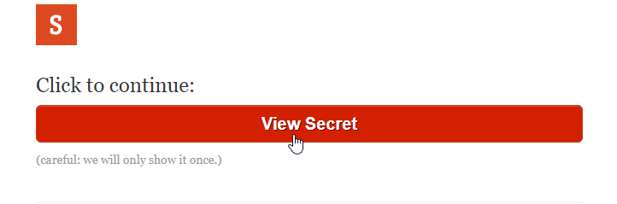

**You will only be able to view your password one time using this link, so make sure you keep it somewhere safe!** After selecting “View secret” you will see the password that you will be able to use to log in. [**NOTE:** The password in this screenshot is not the same as the password you will received when viewing the password link that has been sent to you]

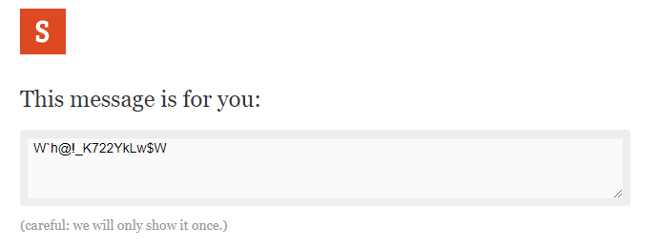

We recommend that you change this password to something more memorable upon your first log in. In order to change your password, hover over your initials in the top right corner and select “Account”

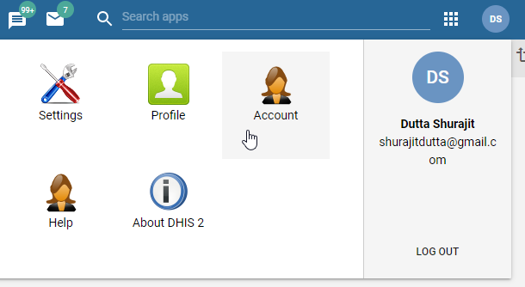

From the account page, enter the password we have sent you through the onetimesecret link, along with a new password of your choice in the “new password” and “repeat new password” fields.

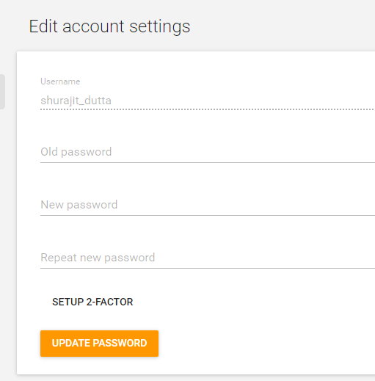

If you have any questions about your account, please contact us @ admin@dhis2nigeria.org.ng

## Generating a Password (for users without an email/bulk generation)

Follow this procedure to create a password for the DHIS2 user account:

1. Navigate to <https://passwordsgenerator.net/plus/>
2. Change the password length to 10
3. Change the quantity to the number of passwords you need to make
4. Copy the password
5. Navigate to DHIS2 and add the password that you have copied from <https://passwordsgenerator.net/plus/>
6. Save the user after all of their details are complete
7. Repeat steps 4-6 for each user, moving down the list of passwords that have been generated for each user on <https://passwordsgenerator.net/plus/>

## Sharing Account Details (for users without an email)

You will run into scenarios in which users do not have an email account and/or may not be able to use email to retrieve and enter account information. This may be particularly true when training facility level staff in large in-person trainings. In this case, generate a strong password for them using the instructions described in the section Generating a Password (for users without an email/bulk generation). You may want to reduce the complexity of the password however; for example by reducing the number of characters from 16 to 10. You will need to share the password manually for each user in your training if they do not have access to regular email. In this scenario, share each password with each user individually. One of the first tasks when reviewing how to login will be to guide users to then update their own passwords.

## 

## Annex A - Generating and Sharing Passwords

1. Navigate to <https://passwordsgenerator.net/>; Leave the default options and select “Generate password”

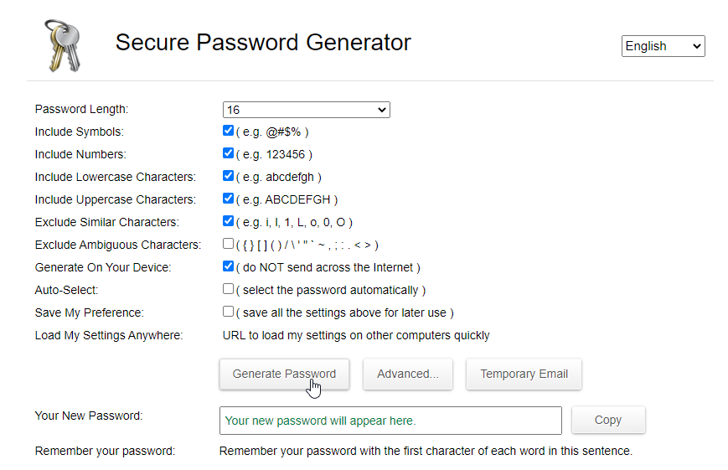

1. Copy the password

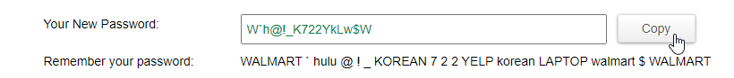

1. When creating a new user in DHIS2, add this password to their account

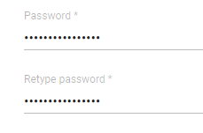

1. Navigate to <https://onetimesecret.com/> and paste the password in the text box that was generated from [https://passwordsgenerator.net](https://passwordsgenerator.net/)

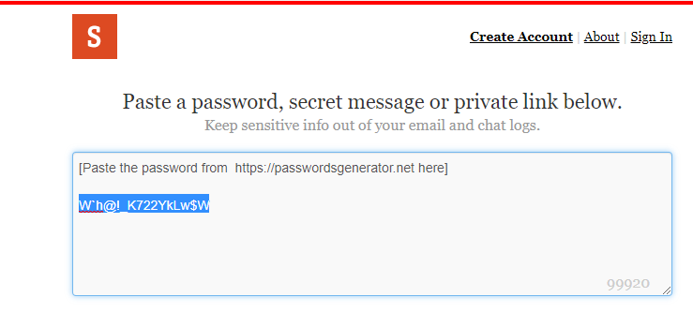

1. Select “Create a secret link”

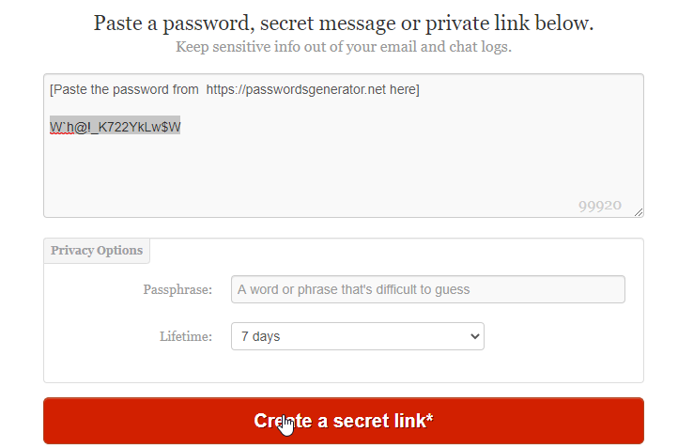

1. Copy the generated link under the text “Share this link”

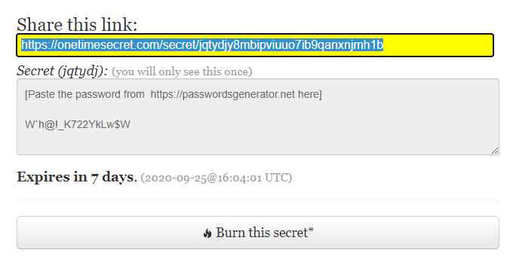

1. Fill in the template email with the generated link and send the email to the user

SUBJECT : HMIS Nigeria Login Details

Dear [Name]

Please find your account details for <https://dhis2nigeria.org.ng/dhis>.

Username : [dhis2 username]

Password : [link to one time secret link]

To view your password, please click on the password link. This link will be available for the next 7 days. After you click on the link, click on “View secret.”



**You will only be able to view your password one time using this link, so make sure you keep it somewhere safe!** After selecting “View secret” you will see the password that you will be able to use to log in. [**NOTE:** The password in this screenshot is not the same as the password you will received when viewing the password link that has been sent to you]



We recommend that you change this password to something more memorable upon your first log in. In order to change your password, hover over your initials in the top right corner and select “Account”



From the account page, enter the password we have sent you through the onetimesecret link, along with a new password of your choice in the “new password” and “repeat new password” fields.



If you have any questions about your account, please contact us @ admin@dhis2nigeria.org.ng